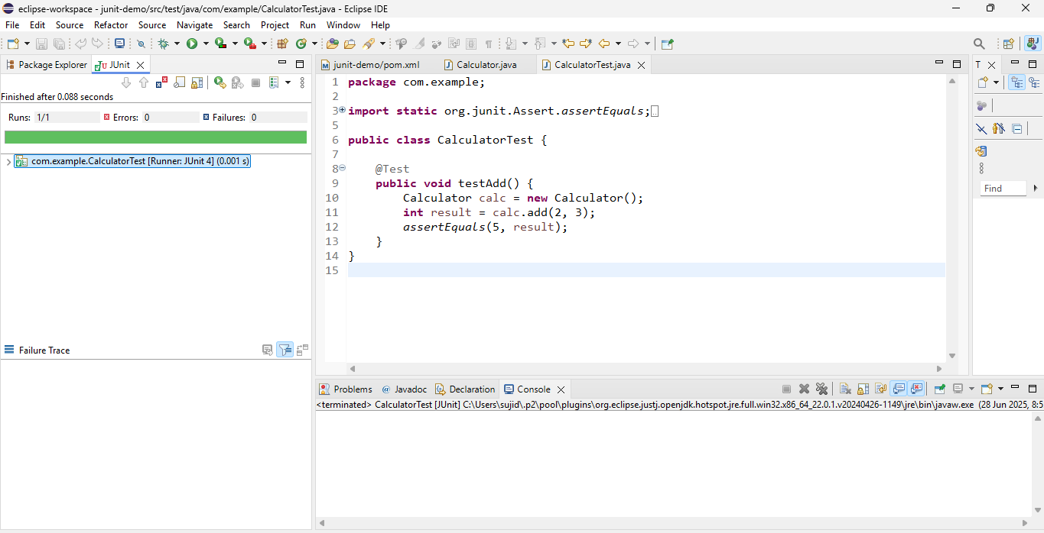Exercise 1: Setting Up JUnit

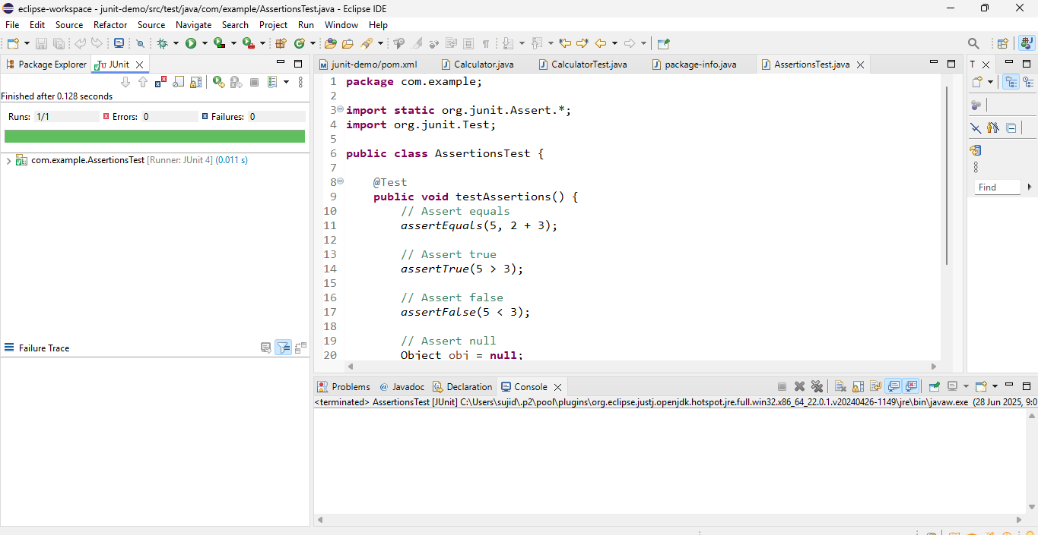Exercise 3: Assertions in Junit

Exercise 4: Arrange-Act-Assert (AAA) Pattern, Test Fixtures, Setup and Teardown Methods in Junit

